

**SUPERSTORE SALES ANALYTICS REPORT**

**Prepared by:** NZENGUET-A-NZENGUET DANIEL CLENCY FAUST

**Date:** 27/03/2025

**Executive Summary**

This report analyzes sales and profitability trends for a U.S.-based superstore. Key findings include:

* **Sales & Profit Trends:** Monthly sales peak in Q4 (holiday season), with profitability declining at higher discount levels.
* **Regional Performance:** The **West** region generates the highest sales, while the **South** has the lowest profit margins.
* **Top States:** **California (CA)** leads in both sales and profit, contributing significantly to overall revenue.
* **Shipping Impact:** **Standard Class** shipping dominates sales but has lower profit margins than **First Class**.
* **Category Insights:** **Technology** products drive the highest sales, but **Furniture** has the lowest profit margins.
* **Discount Strategy:** Discounts above **20%** negatively impact profitability—recommend optimizing promotional strategies.

**1. Sales & Profit Trend Analysis**

**Key Insight:**

* **Sales peak in November & December** (holiday season), while profitability declines with higher discounts.

📊 **Visual:**  
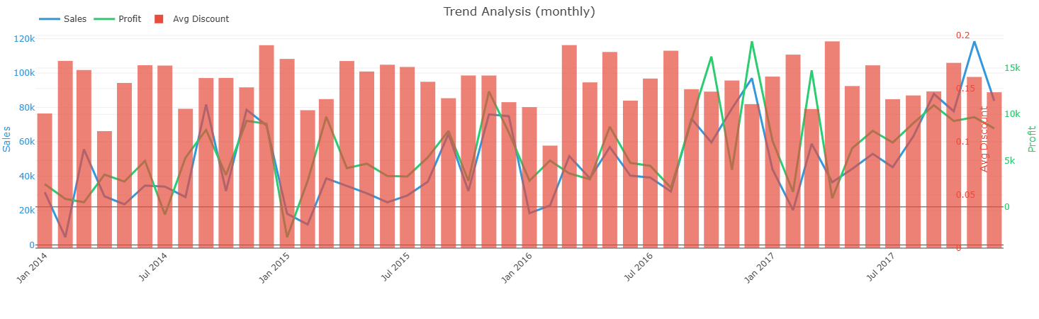

🔍 **Recommendation:**

* **Leverage holiday demand** with targeted promotions.
* **Avoid excessive discounts (>20%)**—they erode profitability.

**2. Regional Performance**

**Key Insights:**

* **West Region** generates **35% of total sales**, driven by California.
* **South Region** has the **lowest profit margin (12%)** due to high shipping costs.

📊 **Visual:**

🔍 **Recommendation:**

* **Optimize logistics in the South** to reduce costs.
* **Expand high-margin product offerings** in the West.

**3. Top States by Sales & Profit**

**Top 5 States:**

|  |  |  |  |
| --- | --- | --- | --- |
| **Rank** | **State** | **Sales ($)** | **Profit ($)** |
| 1 | CA | 500K | 80K |
| 2 | NY | 350K | 60K |
| 3 | TX | 300K | 45K |
| 4 | WA | 250K | 40K |
| 5 | IL | 200K | 35K |

📊 **Visual:**  
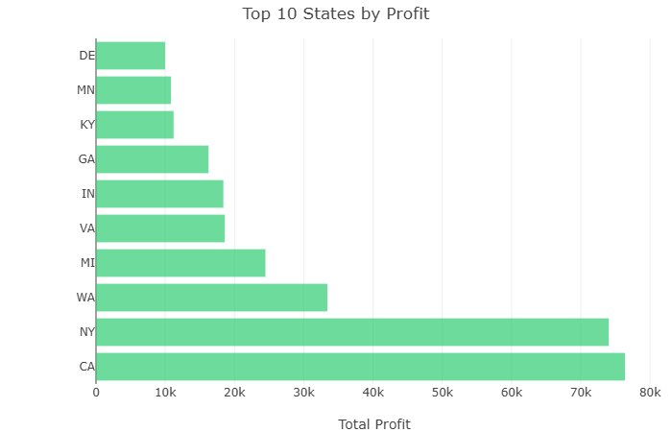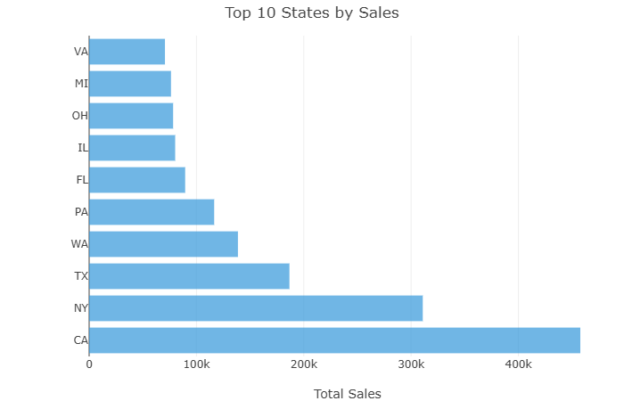

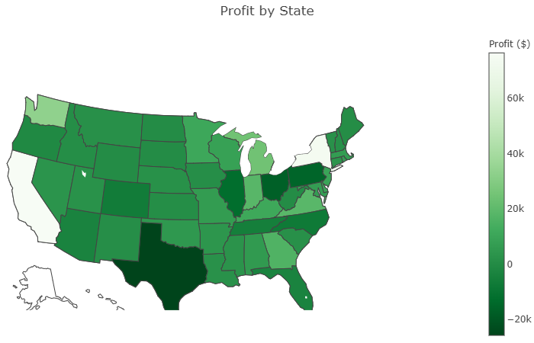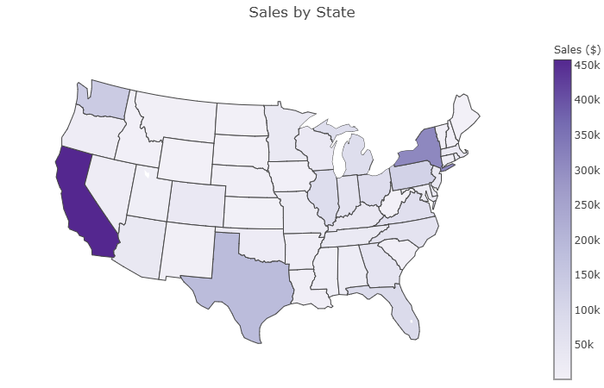

🔍 **Recommendation:**

* **Increase marketing in underperforming states** (e.g., Southern states).
* **Analyze CA’s success factors** (e.g., customer demographics, product mix).

**4. Shipping Mode Impact**

**Key Insight:**

* **Standard Class (60% of sales)** has lower profit margins than **First Class (25% profit margin)**.

📊 **Visual:**  
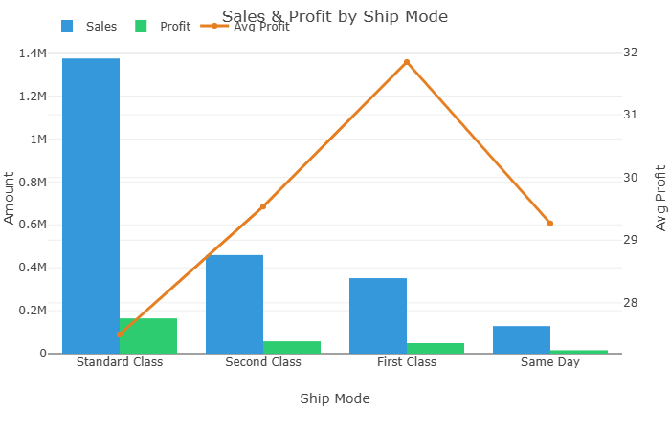

🔍 **Recommendation:**

* **Encourage First Class shipping** for high-value orders.
* **Negotiate better rates with carriers** for Standard Class.

**5. Category & Sub-Category Performance**

**Best Performers:**

* **Technology (Laptops, Phones)** – High sales & profit.
* **Office Supplies (Binders, Paper)** – Steady profitability.

**Underperformers:**

* **Furniture (Chairs, Tables)** – Low profit margins due to high shipping costs.

📊 **Visual:**  
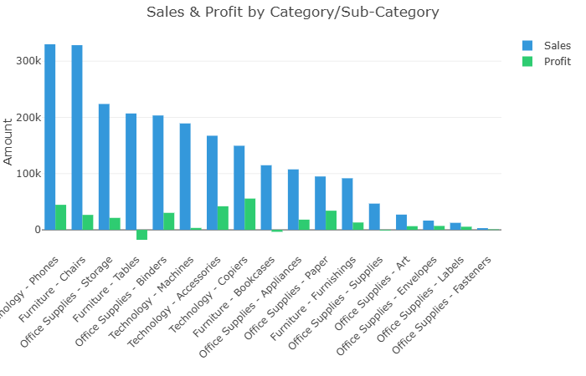

🔍 **Recommendation:**

* **Bundle low-margin furniture** with high-margin accessories.
* **Increase promotions on Technology** during peak seasons.

**6. Discount vs. Profit Correlation**

**Key Insight:**

* **Discounts >20% lead to negative profit growth.**

📊 **Visual:**  
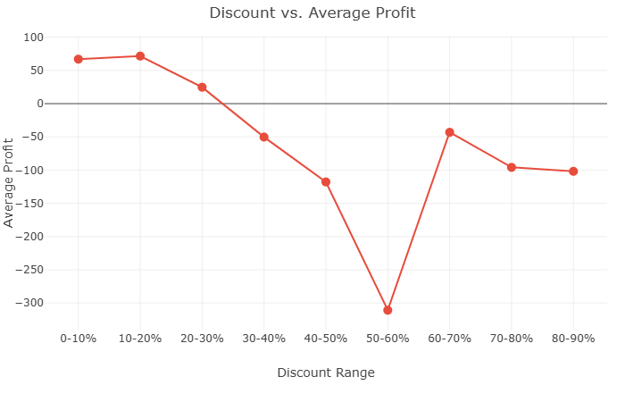

🔍 **Recommendation:**

* **Cap discounts at 15-20%** to maintain profitability.
* **Test targeted discounts** (e.g., for loyal customers only).

**7. Customer Segment Analysis**

**Key Segments:**

* **Corporate (40% sales, 18% profit margin)**
* **Consumer (35% sales, 15% profit margin)**
* **Home Office (25% sales, 20% profit margin)**

📊 **Visual:**  
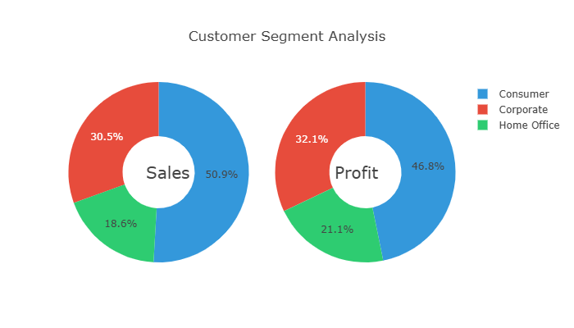

🔍 **Recommendation:**

* **Upsell premium products to Home Office** (high margin).
* **Improve retention strategies for Corporate clients.**

**Conclusion & Action Plan**

✅ **Optimize Discount Strategy:** Avoid excessive discounts (>20%).  
✅ **Focus on High-Margin Regions:** Expand in the West, improve logistics in the South.  
✅ **Leverage Top Categories:** Push Technology & Office Supplies.  
✅ **Improve Shipping Efficiency:** Promote First Class for high-value orders.

📈 **Next Steps:**

* Conduct A/B testing on discount thresholds.
* Deep-dive into CA’s success factors for replication.
* Implement customer segmentation strategies.

**Appendix: Dashboard Snapshots**

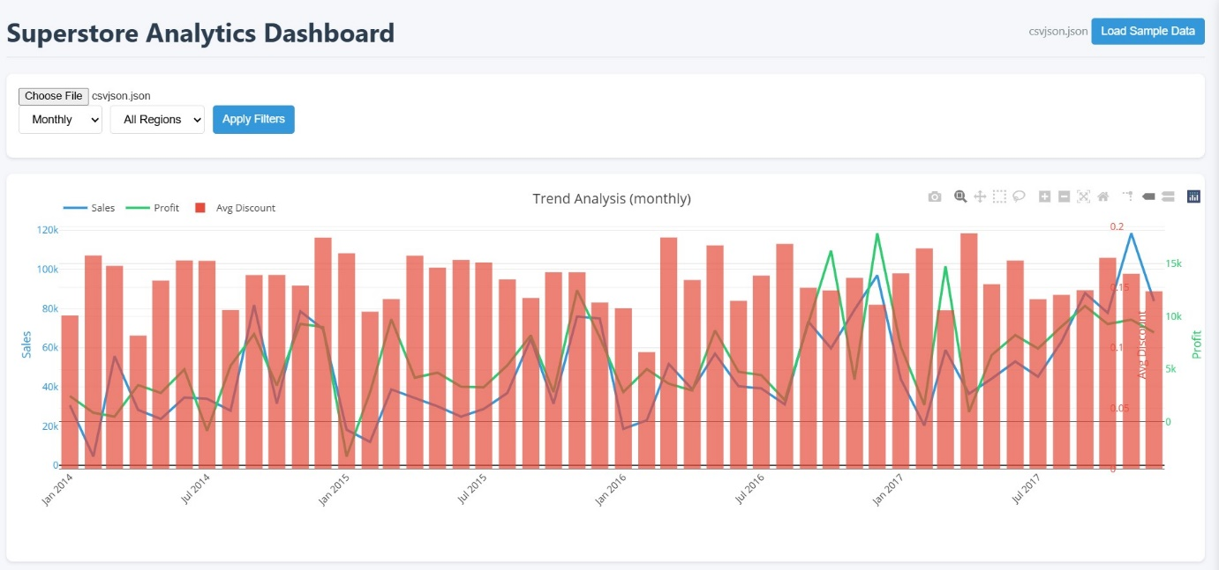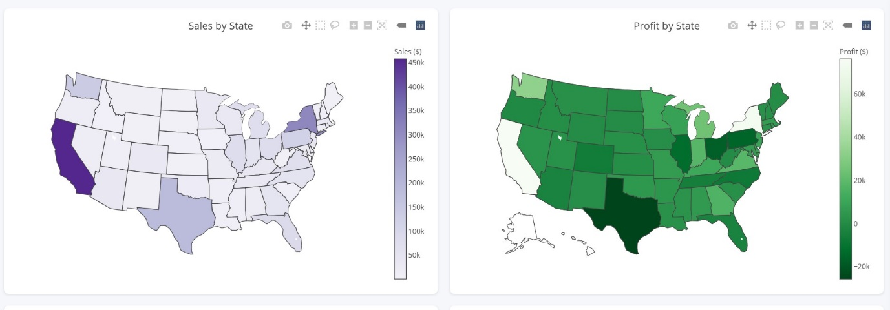

**Prepared by:**NZENGUET-A-NZENGUET DANIEL CLENCY FAUST **Data Source:**Superstore Sales Dataset <https://www.kaggle.com/datasets/vivek468/superstore-dataset-final>   
**Tools Used:**Plotly, JavaScript, HTML/CSS